COMPREHENSIVE REVIEW
GLM-5 vs Claude Opus 4.5
The Open-Source Challenger Takes on the Frontier Leader
An In-Depth Analysis of Benchmarks, User Feedback, and Real-World Performance
February 2026

Executive Summary
The AI landscape witnessed a seismic shift in February 2026 when Zhipu AI released GLM-5, a 744 billion parameter open-source model that directly challenges Anthropic's flagship Claude Opus 4.5. This comprehensive review examines both models across multiple dimensions, revealing a fascinating dichotomy: while Claude Opus 4.5 maintains its position as the intelligence leader with superior benchmark scores, GLM-5 emerges as an unprecedented value proposition that brings frontier-level capabilities to the open-source community at a fraction of the cost. Our analysis draws from official benchmarks, independent evaluations from Artificial Analysis, user feedback from Reddit and developer communities, and real-world performance assessments.
The key finding of this review is that GLM-5 has achieved something remarkable: it scores 50 on the Artificial Analysis Intelligence Index, making it the highest-scoring open-weights model available, while Claude Opus 4.5 leads overall with a score of 70. More importantly, GLM-5 beats Claude Opus 4.5 on specific benchmarks like Humanity's Last Exam (50.4 vs 43.4), demonstrating that open-source models can excel in specific domains. The pricing differential is equally striking: GLM-5 costs approximately 14-16 times less than Claude Opus 4.5 per token, fundamentally changing the economics of deploying frontier-level AI capabilities.

Introduction: The Battle for AI Supremacy
The release of GLM-5 marks a pivotal moment in the ongoing competition between proprietary and open-source AI models. Zhipu AI, a leading Chinese AI research organization, has consistently pushed the boundaries of what open-source models can achieve. With GLM-5, they have scaled from their previous GLM-4.5's 355 billion parameters to a staggering 744 billion total parameters, with 40 billion active parameters in a Mixture-of-Experts (MoE) architecture. This design philosophy represents a calculated bet that scale, combined with efficient inference, can close the gap with proprietary alternatives.
Claude Opus 4.5, released by Anthropic in November 2025, represents the apex of proprietary AI development. It achieved state-of-the-art results on SWE-bench Verified (80.9%), setting a new benchmark for coding capabilities. The model's reasoning abilities, combined with its 200,000 token context window and advanced tool-use capabilities, positioned it as the go-to choice for developers and enterprises requiring maximum AI performance. However, this performance comes at a premium price point of $5 per million input tokens and $25 per million output tokens.
This review aims to provide developers, researchers, and decision-makers with a comprehensive understanding of how these two models compare across the metrics that matter most: raw intelligence, coding ability, cost efficiency, real-world usability, and deployment flexibility. We examine not just the benchmark numbers, but the user experiences and practical considerations that determine actual value in production environments.

Model Architecture and Technical Specifications
Understanding the architectural differences between GLM-5 and Claude Opus 4.5 is essential for appreciating their respective strengths and limitations. GLM-5 employs a Mixture-of-Experts (MoE) architecture, scaling to 744 billion total parameters while maintaining efficiency through 40 billion active parameters during inference. This design draws inspiration from DeepSeek's innovations in sparse activation, allowing the model to achieve frontier-level performance without the computational overhead of dense architectures. The model was trained on 28.5 trillion tokens of data, a significant increase from GLM-4.5's 23 trillion tokens.
Claude Opus 4.5's architecture remains proprietary, though Anthropic has disclosed that it features a 200,000 token context window, significantly larger than GLM-5's 131,072 tokens. This extended context window provides Opus 4.5 with advantages in processing long documents, maintaining conversation history, and handling complex, multi-step reasoning tasks. The model also supports computer use capabilities, allowing it to interact with desktop environments through mouse and keyboard actions, a feature not yet available in GLM-5.
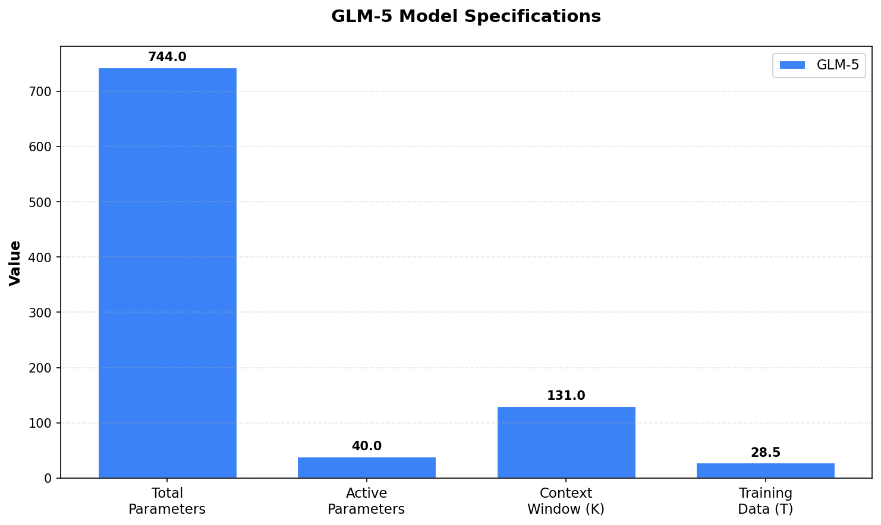
Figure 1: GLM-5 Model Specifications
The most significant architectural difference lies in accessibility. GLM-5 is released under an MIT license, allowing unrestricted commercial use, modification, and distribution. Users can download the model weights directly from Hugging Face and run inference on their own hardware. Claude Opus 4.5, conversely, is only available through Anthropic's API or approved partners, with no option for local deployment. This fundamental difference shapes the entire value proposition of each model, as we explore in subsequent sections.

Benchmark Performance Analysis
Benchmarks provide a standardized way to compare model capabilities, though they should be interpreted with awareness of their limitations. Our analysis draws from multiple independent sources, including Artificial Analysis, SWE-bench official leaderboards, and the models' respective technical reports. The picture that emerges is nuanced: Claude Opus 4.5 leads on most traditional benchmarks, but GLM-5 shows surprising strength in specific domains and offers unprecedented value for an open-weights model.

Artificial Analysis Intelligence Index
The Artificial Analysis Intelligence Index aggregates performance across multiple benchmark suites to provide a holistic intelligence score. Claude Opus 4.5 achieves an impressive score of 70 in reasoning mode, positioning it among the top tier of all models evaluated. GLM-5, with a score of 50, represents an 8-point jump from its predecessor GLM-4.7 (42 points) and establishes itself as the leader among open-weights models. This gap of 20 points between the models reflects real differences in reasoning capability, particularly for complex, multi-step problems.
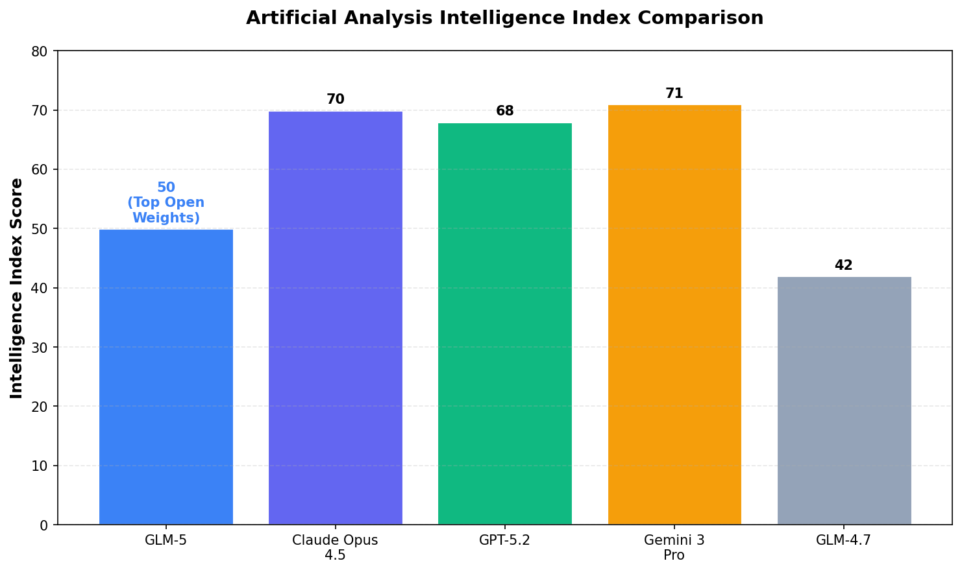
Figure 2: Artificial Analysis Intelligence Index Comparison

SWE-bench Verified: The Coding Benchmark
SWE-bench Verified has emerged as the definitive benchmark for evaluating AI coding capabilities. It tests models on their ability to solve real-world GitHub issues, requiring not just code generation but understanding of existing codebases, debugging skills, and integration capabilities. Claude Opus 4.5 achieved a groundbreaking 80.9% score, the highest recorded at the time of its release, demonstrating exceptional ability to understand and modify production-quality code.
GLM-5's 77.8% score on SWE-bench Verified places it firmly in the same tier as leading proprietary models, outperforming Gemini 3 Pro (76.2%) and approaching parity with Claude Opus 4.5. This represents a significant achievement for an open-source model and validates Zhipu AI's focus on coding and agentic capabilities. The 3.1 percentage point gap between GLM-5 and Opus 4.5 is meaningful but not decisive; both models can handle the vast majority of real-world coding tasks effectively.

Reasoning and Knowledge Benchmarks
On GPQA (Graduate-Level Google-Proof Q&A), Claude Opus 4.5 achieves 87.0%, reflecting its strong performance on questions requiring deep domain expertise. GLM-5 scores approximately 82%, a competitive result that places it ahead of many proprietary alternatives. The MMMLU benchmark, which aggregates performance across academic disciplines, shows Claude Opus 4.5 at 90.8% versus GLM-5 at approximately 89%, indicating near-parity in broad knowledge assessment.
Perhaps most surprisingly, GLM-5 outperforms Claude Opus 4.5 on Humanity's Last Exam, a benchmark designed to test novel problem-solving abilities. GLM-5 achieves 50.4% with tool access, compared to Opus 4.5's 43.4%, demonstrating that the open-source challenger can exceed the frontier leader in specific domains. This result suggests that GLM-5's training on diverse, high-quality data has equipped it with unique problem-solving capabilities that complement its coding strengths.
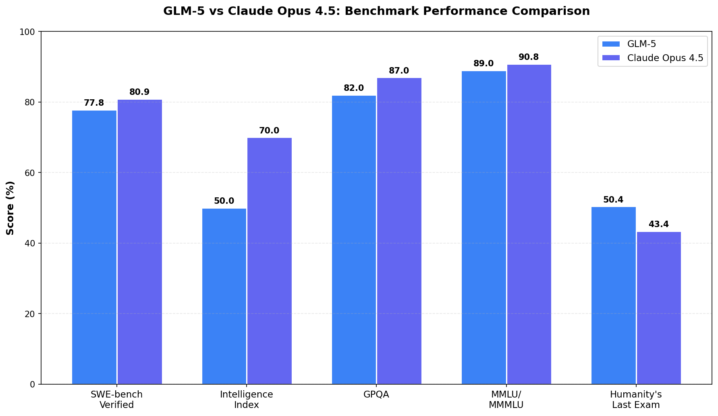
Figure 3: GLM-5 vs Claude Opus 4.5 Benchmark Performance Comparison

Coding and Agentic Capabilities
The practical utility of an AI model for software development depends not just on benchmark scores but on real-world coding performance. Both GLM-5 and Claude Opus 4.5 have been extensively tested by developers, and the feedback reveals complementary strengths. Claude Opus 4.5 excels at complex, multi-file refactoring tasks and demonstrates superior performance on Terminal-Bench (59.3% vs GLM-5's estimated 42%), indicating stronger capabilities in command-line environments and system administration tasks.
GLM-5, however, shows exceptional strength in tool calling and API integration. On tool calling benchmarks, GLM-5 achieves 90.6% accuracy, slightly exceeding Claude Opus 4.5's 89.5%. This capability is crucial for building agentic applications where the AI must interact with external services, databases, and APIs. Zhipu AI's internal CC-Bench-V2 shows GLM-5 significantly outperforming GLM-4.7 across frontend, backend, and long-horizon tasks, validating the model's design focus on practical software engineering.
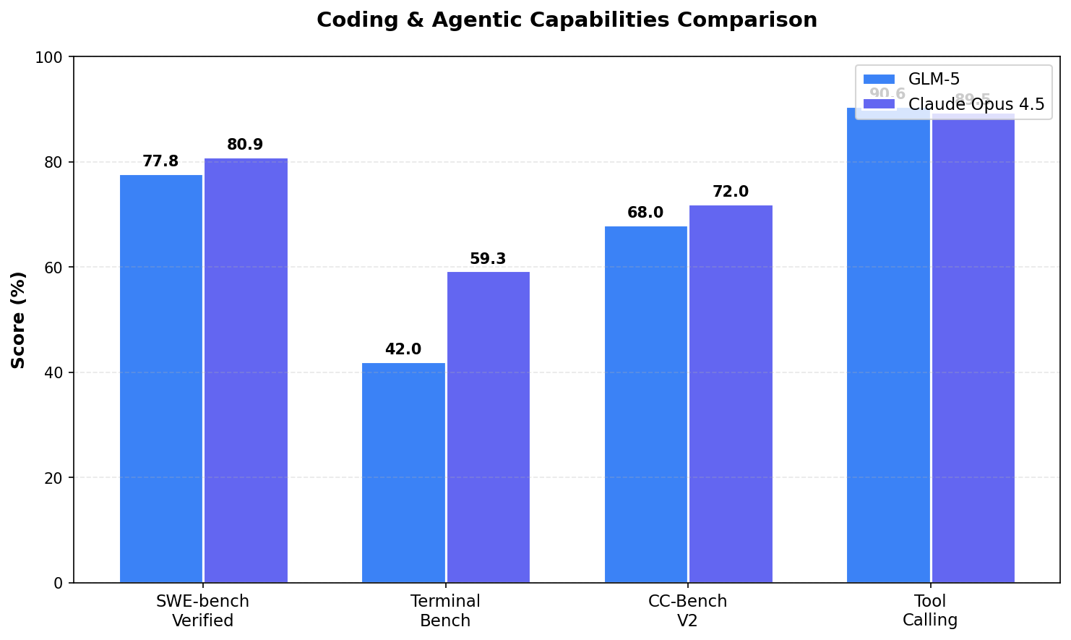
Figure 4: Coding and Agentic Capabilities Comparison
User feedback from Reddit and developer communities provides valuable context for these benchmark results. Multiple users report that while Claude Opus 4.5 handles larger, more complex tasks with greater reliability, GLM-5 offers surprisingly good performance for its cost. A common sentiment expressed by developers is that GLM-5 is "sufficient for most coding tasks" and represents an "insane value" for the price. YouTube reviews have shown GLM-5 successfully building complex applications, including games and full-stack projects, with one reviewer calling it "the best open-source coding model."

User Feedback and Community Response
Beyond benchmarks, user experiences provide crucial insights into real-world model performance. The response to both models has been enthusiastic but differentiated. Claude Opus 4.5 has generated significant excitement in developer communities, with Reddit users describing it as "so good that everything else is well noise" and warning that "Opus 4.5 needs to calm down" due to its impressive productivity boost. Developers report being able to complete in hours what previously took days, though some express concern about over-reliance on AI for coding tasks.
GLM-5 has received more mixed but generally positive feedback. Early users on Reddit note that while "GLM models aren't great for tackling huge tasks themselves," they work well when combined with other tools in a workflow. Some users reported being "greatly unimpressed" with initial experiences, while others found specific coding sessions to be "the best ever" they had seen. The consensus appears to be that GLM-5 is an excellent choice for cost-conscious developers who need capable coding assistance without the premium price tag of Opus 4.5.
A notable concern raised by the community involves Zhipu AI's implementation of guardrails in GLM-5. Users have reported encountering restrictions when attempting certain tasks, suggesting that the model includes safety mechanisms that may limit some use cases. This contrasts with Claude Opus 4.5, which also has safety guardrails but has been tuned for more permissive use in professional coding contexts. Users should evaluate both models against their specific requirements to determine which approach better suits their needs.

Pricing and Value Analysis
The pricing differential between GLM-5 and Claude Opus 4.5 represents perhaps the most significant consideration for organizations choosing between these models. Claude Opus 4.5 is priced at $5 per million input tokens and $25 per million output tokens, positioning it as a premium offering for users who require maximum capability. For large-scale applications processing millions of tokens daily, these costs can become substantial, potentially reaching thousands or tens of thousands of dollars monthly.
GLM-5, in contrast, offers API access through Z.ai at approximately $0.35 per million input tokens and $1.40 per million output tokens, representing a 14-16x cost advantage. For organizations with high-volume AI workloads, this difference can translate to hundreds of thousands of dollars in annual savings. Furthermore, because GLM-5 is open-source, users can run inference on their own hardware, eliminating API costs entirely in exchange for infrastructure investment. This flexibility makes GLM-5 particularly attractive for applications with strict data residency requirements or budget constraints.
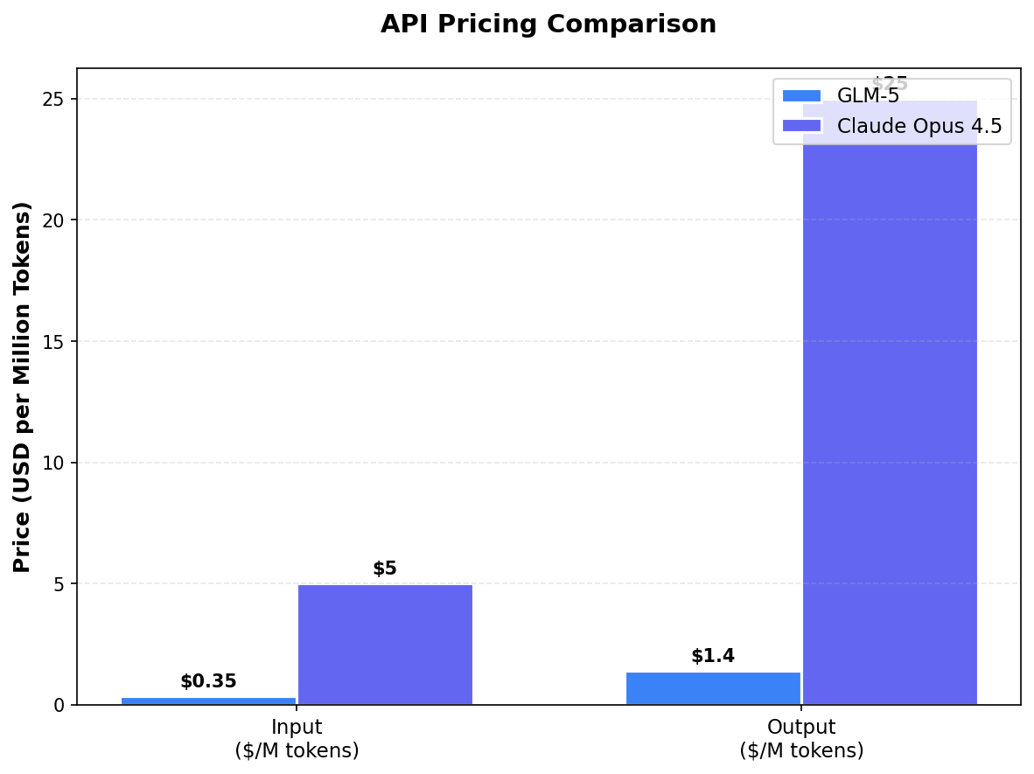
Figure 5: API Pricing Comparison
However, the total cost of ownership calculation is more nuanced than simple API pricing. Running GLM-5 locally requires significant hardware resources: the 744 billion parameter model demands multiple high-end GPUs with substantial VRAM. Users on Reddit have noted that "the real cost is hardware," and some have reported that Z.ai's hosted service can become slow during peak usage. Organizations must weigh the per-token savings against infrastructure costs and potential availability concerns when making their decision.

Overall Capability Assessment
To provide a holistic view of how these models compare, we assessed them across six key dimensions: coding capability, reasoning ability, agent functionality, cost efficiency, open-source availability, and context window size. The radar chart below visualizes these assessments, illustrating the complementary strengths of each model. Claude Opus 4.5 excels in reasoning and context handling, while GLM-5 offers superior cost efficiency and the unique advantage of open-source availability.
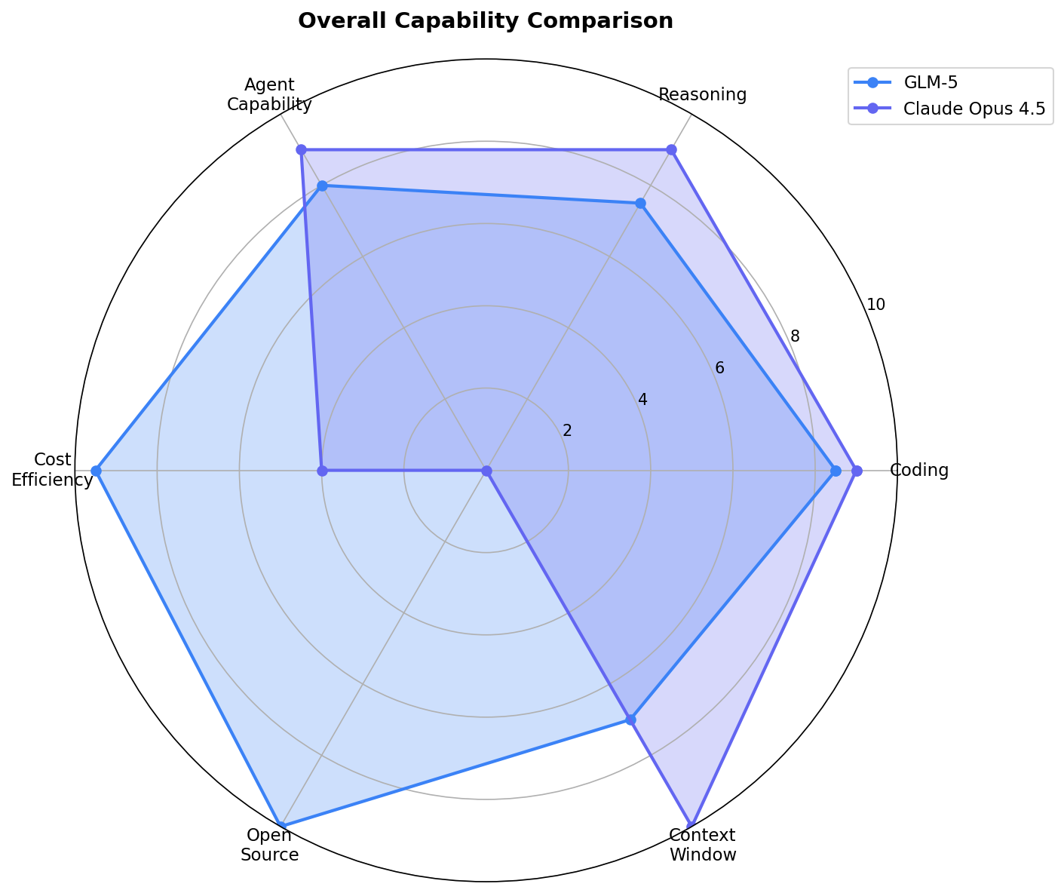
Figure 6: Overall Capability Comparison

Recommendations and Use Cases
Based on our comprehensive analysis, we offer the following recommendations for different use cases and organizational profiles. These recommendations should be considered alongside specific requirements and constraints that may affect their applicability.
Choose Claude Opus 4.5 when:
- Maximum reasoning capability is required for complex problem-solving tasks
- Long context windows are needed for processing extensive documents or maintaining long conversations
- Computer use capabilities (desktop automation) are essential
- Budget is not a primary constraint
- Reliable, low-latency API access is critical for production systems
Choose GLM-5 when:
- Cost efficiency is a primary concern, especially for high-volume applications
- Data residency or privacy requirements necessitate local deployment
- You need to customize or fine-tune the model for specific domains
- Open-source licensing is required for compliance or strategic reasons
- Tool calling and API integration are primary use cases

Conclusion
The comparison between GLM-5 and Claude Opus 4.5 reveals an evolving AI landscape where proprietary excellence and open-source accessibility are converging. Claude Opus 4.5 remains the benchmark leader, offering superior reasoning capabilities, larger context windows, and polished production-ready API access. For organizations requiring maximum capability and willing to pay premium prices, it represents the clear choice.
However, GLM-5 has achieved something remarkable: it has brought frontier-level AI capabilities to the open-source community at an unprecedented price point. Its 77.8% SWE-bench score, 50-point Intelligence Index, and victory on Humanity's Last Exam demonstrate that the gap between proprietary and open-source models is narrowing rapidly. For the vast majority of practical applications, GLM-5 offers sufficient capability at a fraction of the cost.
The real winner in this comparison is the AI community. Competition drives innovation, and the presence of a credible open-source challenger pushes proprietary providers to continue improving. As we move forward, we expect this dynamic to accelerate, with benefits flowing to developers, researchers, and end users across the ecosystem.

Benchmark Summary Table

Benchmark | GLM-5 | Claude Opus 4.5
SWE-bench Verified | 77.8% | 80.9%
Intelligence Index | 50 | 70
GPQA | ~82% | 87.0%
MMMLU | ~89% | 90.8%
Humanity's Last Exam | 50.4% | 43.4%
Tool Calling | 90.6% | 89.5%
Terminal-Bench | ~42% | 59.3%
Context Window | 131K tokens | 200K tokens
License | MIT (Open Source) | Proprietary
Input Price ($/M) | $0.35 | $5.00
Output Price ($/M) | $1.40 | $25.00
Table 1: Comprehensive Benchmark and Feature Comparison (Green = Winner)

References and Sources
- Z.ai Official GLM-5 Announcement: https://z.ai/blog/glm-5
- Anthropic Claude Opus 4.5 Introduction: https://www.anthropic.com/news/claude-opus-4-5
- Artificial Analysis GLM-5 Analysis: https://artificialanalysis.ai/articles/glm-5-everything-you-need-to-know
- Artificial Analysis Opus 4.5 Benchmarks: https://artificialanalysis.ai/articles/claude-opus-4-5-benchmarks-and-analysis
- SWE-bench Official Leaderboard: https://www.swebench.com
- Reddit r/LocalLLaMA Discussion: https://www.reddit.com/r/LocalLLaMA/
- VentureBeat GLM-5 Coverage: https://venturebeat.com/technology/z-ais-open-source-glm-5-achieves-record-low-hallucination-rate
- Hugging Face Model Card: https://huggingface.co/zai-org/GLM-5
- LLM Stats Comparison: https://llm-stats.com/models/compare/claude-opus-4-5-20251101-vs-glm-4.5

